To create the dataset for this study, the following steps were taken.

I use R version x.x.x to obtain census block level population data using the package tidycensus. Population data at the census block level was obtained for all states with each state being its own fie. This data was then brought into ArcGIS Pro and looped together to be one dataset of population blocks.

PWS data was merged with the EPA community water system boundaries that are publicly available. This data was merged together in R. After the data was merged, it was brought into ArcGIS Pro.
A layer of US census tracts was also brought into ArcGIS Pro.
To assign water system values to census tracts we first needed to combine the census tracts and PWS contaminant data.
Check the spatial reference of each layer. Merged data and census blocks should be the same projection and census tracts need to be projected using the project tool so that all layers are the same.
There are census tracts that fall completely within the water system boundaries and some that intersect water systems. To identify the census tracts that are served by multiple water systems:
  - For tracts fully within, start by using select by location to select tracts fully within water system boundaries. Export the selected data from the census tracts layer into a layer called tracts_fully_within
    - 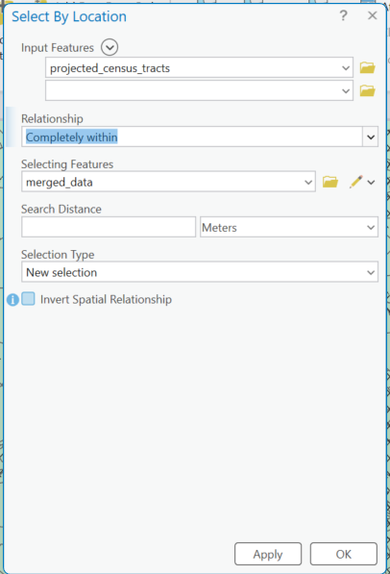
  - Next use a spatial join to join the pws data with the fully within tracts so that the tracts are assigned the value of the water system serving them
    - 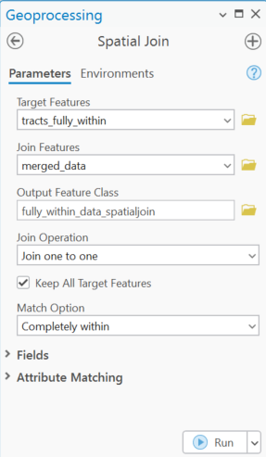
- For tracts that are split by multiple water systems we need to intersect the census tracts with the pws boundaries
  - Geoprocessing intersect
    - Input features: census tracts, water system boundaries (merged data)
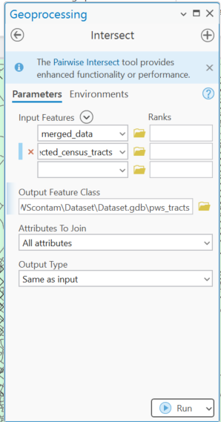
- Perform a spatial join to count intersections
  - Geoprocessing spatial join
    - Target features: tracts_water system intersected layer (pws_tracts)
    - Join features: water systems (merged data)
    - Join operation: one- to- one
    - Match option: intersect
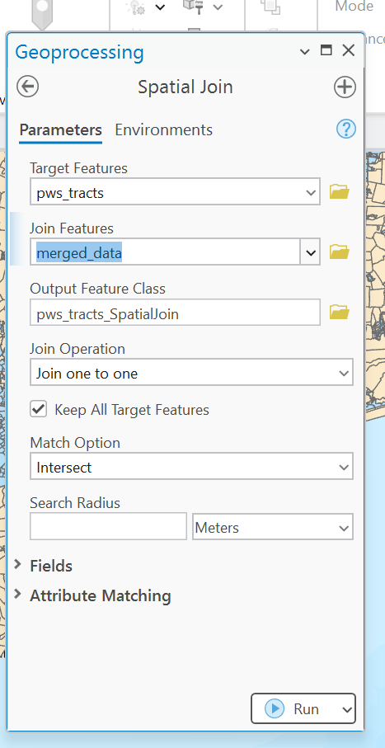
  - Join_count is a field that is automatically generated when you run this tool
    - Join_count = 1 means that the tract is fully within a water system boundary
    - Join_count > 1 means that the tract is split across multiple water systems and these are the tracts that need to be population weighted
- To separate the tracts that need to be population weighted, select by attribute
  - New selection
  - Join_count greater than 1
  - Click OK to select these tracts
  - Right click the layer in the contents pane, go to data export features to save as a new layer of tracts that need to be population weighted
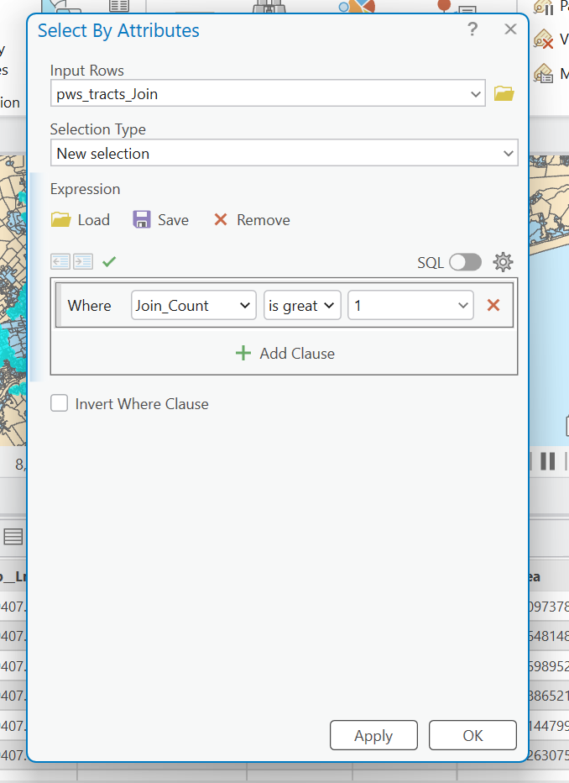
- To population weight
  - Join the census blocks to water systems using spatial join
    - Why? Population wights need to happen at the smaller geographical level before aggregating
    - Target features> census blocks
    - Join features: water systems
    - Join operation: one- to- many (each block gets the contaminant values of the water system it intersects)
    - Output fields: census block population, contaminant values
    - Export the layer
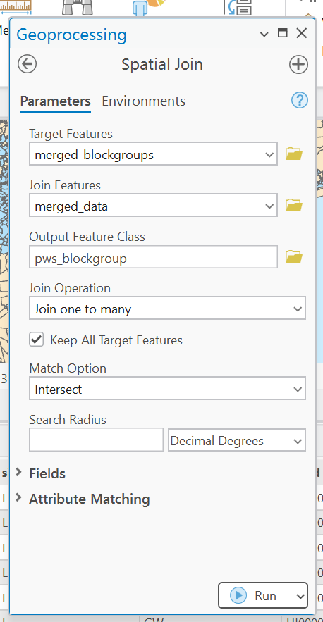
  - Calculate the population weights
    - Use intersect tool to intersect the census blocks with the tracts that are joined to the water system
      - Input features: split tracts, blocks joined w/ water system data
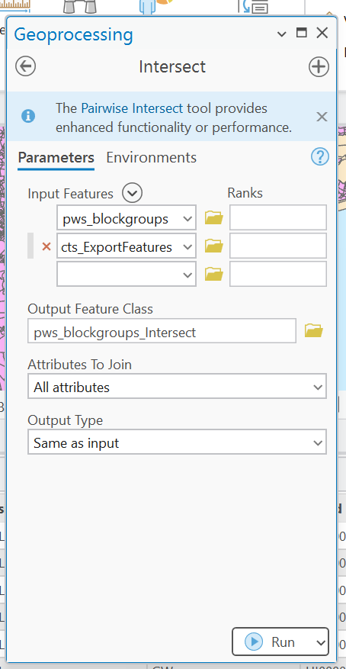
    - Add a new field: pop_weight
      - Geoprocessing summary statistics
        - Input table: split_tract_blocks
        - Statistics field: value (population at the census block group level)
        - Statistic type: sum
        - Case field:GEOID10 (of the census tract, not blockgroup)
        - Run
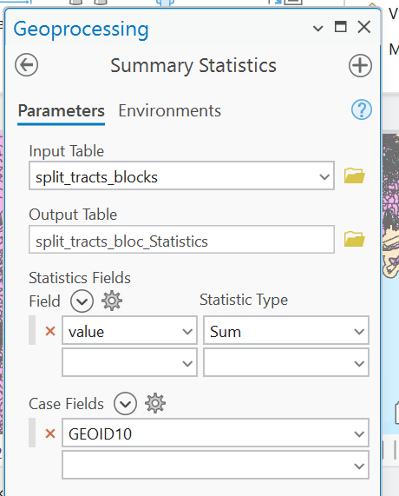
      - Join summarized data back to split_tracts_block; join by GEOID10 (census tract)
        - Geoprocessing join field
          - Input: split tract blocks
          - Input field: geoid10 (census tract)
          - Join table: split_tract_blocks_statitstics
          - Join field: geoid10 (census tract)
          - Transfer fields: sum_value (this is the sum of all of the population of all of the blocks in the census tract)
          - Use calculate field to calculate the population weight
            - Population weight= value/ sum value
            - Value is population in the census block
            - Sum_value is population of the census tract
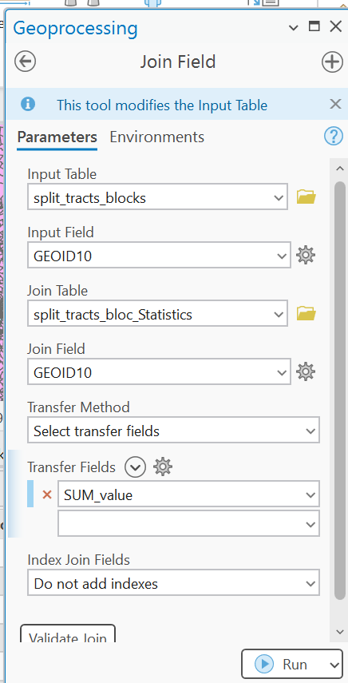

    - Multiply values by the population weight to get contaminant value for contaminants at the census block
      - Create new columns for the weighted values then multiply original value by population weight in this column
    - Summarize split tracts by census tract to get the contaminant value at the census tract level
      - Geoprocessing summary statistics
        - Input: split blocks layer
        - Case field: GEOID10 (census tract)
        - Statistics: population weighted contaminant field
        - Statistic type: sum
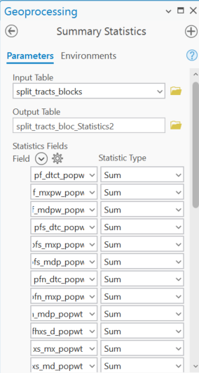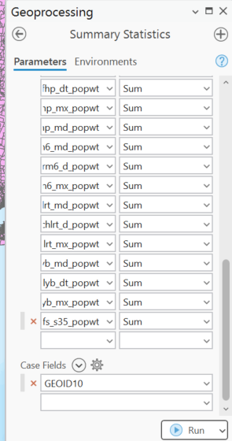
    - Join the summary back to split blocks
      - Select the split_tracts layer in the contents then right click
      - go to join
        - input: split_tract
        - input join field: GEOID (of census tract)
        - Join table: summarized results of the second statistics table
        - Join table field: GEOID
        - Join type: keep all records
        - Join operation: one to many
